**Cyber Security threats and mitigations in the Healthcare Sector with emphasis on IoMT security and Software Defined Networking**

Pemarathna I.R.C

Department of Computer Systems Engineering

Sri Lanka Institute of Information Technology

[it21170416@my.sliit.lk](mailto:it21170416@my.sliit.lk)

**Abstract**

The combination of Internet of Medical Things (IoMT) and Software Defined Networking (SDN) technologies has significantly changed the healthcare industry. While these developments have transformed patient care and data management, they have also made the industry vulnerable to unheard-of cybersecurity risks. This study review paper offers a thorough examination of the rapidly changing cybersecurity environment in healthcare, with an emphasis on the unique difficulties brought on by IoMT and SDN technologies. This study provides a detailed perspective of the dangers and vulnerabilities encountered by healthcare organizations by drawing conclusions from a variety of research studies.

This paper's first portion examines the changing healthcare landscape and highlights the crucial role that IoMT devices play in gathering, transmitting, and storing private patient data. We carefully examine a variety of cybersecurity risks that IoMT must deal with, such as data breaches, unauthorized access, and compromised devices. The study also emphasizes how crucial it is to have secure communication protocols, reliable authentication systems, and data encryption in order to protect patient data and guarantee the reliability of healthcare services.

The incorporation of SDN into healthcare networks, which provides improved flexibility and management capabilities, is explored in the second section of the article. However, because of network-based attacks and SDN controller weaknesses, this integration poses new security risks. Intrusion detection systems and network segmentation are just two examples of the mitigation techniques for these threats that are covered in detail.

The document synthesizes information from other research review papers to give a thorough assessment of the situation of cybersecurity in the healthcare industry today. As crucial elements of a comprehensive cybersecurity strategy, policy formulation, security awareness and training, and continual research and development are emphasized.

In conclusion, this study review paper provides a thorough overview of the healthcare industry's cybersecurity landscape, particularly in light of IoMT and SDN. It emphasizes the significance of solving cybersecurity concerns to enable the continuous growth of healthcare technologies while preserving patient safety and data privacy, acting as a significant resource for healthcare practitioners, researchers, and politicians.

1. **INTRODUCTION**

The healthcare field has a role, in our society as it offers services that directly affect people’s lives. With the advancement of technology, the healthcare industry has embraced digitalization more and more resulting in enhancements in patient care, medical research and administrative efficiency. However, this transition to a world has also exposed healthcare organizations to increased cyber threats. Two key areas of concern, in healthcare cybersecurity are the Internet of Medical Things (IoMT) and Software Defined Networking (SDN).

The Internet of Medical Things (IoMT) is a growing network of interconnected devices. This network includes devices, like health trackers, smart infusion pumps, imaging equipment and electronic health record systems. While IoMT devices have advantages such as real time monitoring, patient outcomes and increased efficiency they also come with security risks. Malicious individuals can exploit these risks to gain access compromise patient data or manipulate medical devices. This poses a threat, to the safety of patients.

At the time Software Defined Networking (SDN) is completely changing the way healthcare organizations handle and protect their network infrastructure. SDN simplifies network control, by allowing for setup and management of network resources using software than relying solely on traditional hardware methods. This flexibility and adaptability are extremely valuable for healthcare facilities dealing with constantly evolving network requirements. However this shift, in approach also brings about considerations in terms of cybersecurity as software defined networks may present ways for hackers to attack and therefore necessitate strong security measures to safeguard patient data and vital healthcare systems.

This research paper will explore the cybersecurity challenges faced by the healthcare industry focusing primarily on how to mitigate threats, within the realms of IoMT (Internet of Medical Things) and SDN (Software Defined Networking). We will delve into the risks associated with IoMT devices, such as vulnerabilities that have not been patched potential data breaches and concerns regarding privacy. Additionally we will discuss strategies to secure these assets. Furthermore we will examine the changing landscape of software defined networking in healthcare and address vulnerabilities while providing practices to enhance security.

In today’s healthcare landscape, where providers heavily rely on interconnected devices and software defined networks to deliver high quality care it becomes crucial for cybersecurity to be a priority. The purpose of this paper is to offer insights and guidance for healthcare professionals IT administrators and policymakers as they navigate the realm of healthcare cybersecurity, in the era of IoMT and SDN.

2: Internet of Medical Things (IoMT) 2.1 Definition and Significance of IoMT in Healthcare:

The Internet of Medical Things (IoMT) refers to the interconnected network of medical devices and equipment that collect, transmit, and exchange healthcare data over the internet. IoMT has profound significance in healthcare: Remote Patient Monitoring: IoMT enables real-time monitoring of patient health, allowing healthcare providers to intervene promptly. Efficient Healthcare Delivery: It streamlines healthcare processes, reducing costs and improving the quality of care. Data-Driven Decision Making: IoMT generates vast amounts of patient data for analysis, aiding in diagnosis and treatment. 2.2 Benefits and Challenges of IoMT Adoption: Benefits: Enhanced Patient Care: IoMT facilitates continuous patient monitoring, reducing hospital readmissions. Efficiency: Streamlined data collection and sharing enhance healthcare processes. Cost Savings: Remote monitoring and early detection reduce healthcare costs. Personalized Medicine: Data from IoMT devices enables personalized treatment plans. Challenges: Security Concerns: IoMT devices are vulnerable to cyberattacks, compromising patient data. Interoperability: Compatibility issues between different IoMT devices and systems can hinder seamless data exchange. Privacy: Concerns about the privacy of patient data collected by IoMT devices. Regulatory Compliance: Compliance with healthcare regulations, such as HIPAA, is essential but challenging. 2.3 Common Cybersecurity Threats Specific to IoMT: Cybersecurity threats in IoMT are a growing concern: Device Tampering: Unauthorized access or manipulation of IoMT devices. Data Breaches: Theft or exposure of sensitive patient health data. Denial-of-Service (DoS) Attacks: Disruption of IoMT device functionality. Malware: IoMT devices can be infected with malware, compromising their operations. 2.4 Examples and Case Studies: Medtronic Insulin Pump Vulnerability: In 2019, a vulnerability was discovered in Medtronic's insulin pumps that could be exploited remotely, highlighting the need for IoMT security. St. Jude Medical Cardiac Devices: In 2017, security vulnerabilities in St. Jude Medical's cardiac devices raised concerns about patient safety in IoMT. This section emphasizes the significance of IoMT in healthcare, its benefits, challenges, cybersecurity threats, and real-world examples to illustrate the importance of robust security measures. Ensure to cite relevant sources and research papers when using information from the provided search results to support the content of this section.

1. **Internet of Medical Things (IoMT)**

**2.1 Definition and Significance of IoMT in Healthcare:**

The Internet of Medical Things (IoMT) refers to the interconnected network of medical devices and equipment that collect, transmit, and exchange healthcare data over the internet. IoMT has profound significance in healthcare:

Remote Patient Monitoring: IoMT enables real-time monitoring of patient health, allowing healthcare providers to intervene promptly.

Efficient Healthcare Delivery: It streamlines healthcare processes, reducing costs and improving the quality of care.

Data-Driven Decision Making: IoMT generates vast amounts of patient data for analysis, aiding in diagnosis and treatment.[[1]](https://www.sciencedirect.com/science/article/pii/S0925231223008421)

[Figer 1](https://ars.els-cdn.com/content/image/1-s2.0-S0925231223008421-gr1.jpg)

**2.2 Benefits and Challenges of IoMT Adoption:**

**Benefits:**

* **Enhanced Patient Care:** IoMT facilitates continuous patient monitoring, reducing hospital readmissions.
* **Efficiency:** Streamlined data collection and sharing enhance healthcare processes.
* **Cost Savings:** Remote monitoring and early detection reduce healthcare costs.
* **Personalized Medicine:** Data from IoMT devices enables personalized treatment plans.

**Challenges:**

Security Concerns: IoMT devices are vulnerable to cyberattacks, compromising patient data.

* **Interoperability:** Compatibility issues between different IoMT devices and systems can hinder seamless data exchange.
* **Privacy:** Concerns about the privacy of patient data collected by IoMT devices.
* **Regulatory Compliance:** Compliance with healthcare regulations, such as HIPAA, is essential but challenging. [[2]](https://ieeexplore.ieee.org/document/10029214)

----------------------------------------

**2.3**

**2.4 Examples and Case Studies :**

**CASE STUDIES**

The case studies and analysis presented in this part are based on experimental investigations on PUF, AI-enabled SDN, and blockchain.

E-healthcare

**PUF-based Authentication**

A summary of our suggested PUF-based authentication infrastructure, which uses the e-health

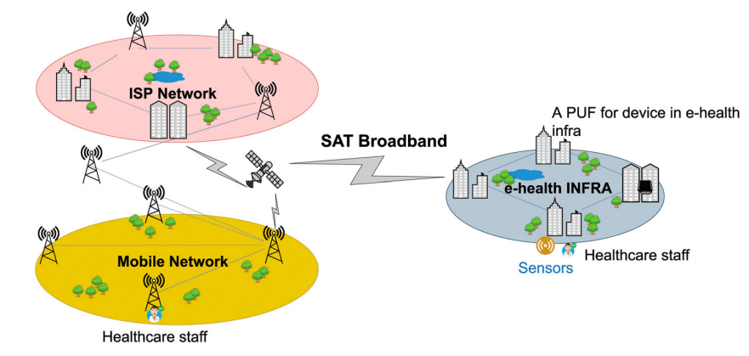

Figure 3 PUF-based authentication overview

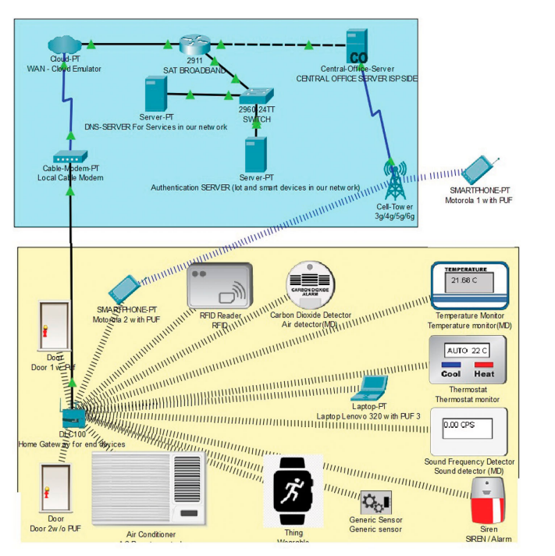

Figure 4: Detailed simulated topology over Cisco packet tracer

The e healthcare infrastructure consists of IoMT PUF devices that are connected via a satellite broadband network along, with an Internet Service Provider (ISP) and mobile networks. Through this system we demonstrate how healthcare professionals can remotely authenticate and access IoMT devices using a PUF based mechanism on their devices. Figure 4 provides an overview of the connected devices, in this framework. To simulate the setup we utilize Cisco packet tracer, a simulation tool. In the e healthcare infrastructure all IoMT devices are. This network is established by configuring a Satellite broadband router (SAT).

Figure 5: Remote server authentication

To enable secure connections and authentication for IoT and IoMT devices in an e-health ecosystem, you have built a fog-cloud architecture in this scenario using a variety of factors. A succinct and sympathetic explanation of the setup is provided below:

**Overview of architecture**

You've created a fog-cloud architecture that utilizes a WAN Cloud Emulator to connect multiple devices, including IoT and IoMT devices.

To connect end devices to the Internet Service Provider (ISP) through a cable modem and control traffic redirection, a DLC100 Home Gateway is included.

Smartphones connected to 3G, 4G, or 5G networks do so via a cell tower.

**Process of authentication:**

The e-health ecosystem's device authentication is the main topic of discussion.

DHCP IP configurations are being used to imitate 13 end devices.

Through a decentralized server approach, devices are verified.

Device authentication is carried out using PUF (Physically Unclonable Function) signatures and an authentication server with the IP address 10.0.0.253.

For device registration and remote management, an administrator account is made.

**Configurations for devices:**

Each device, including the Motorola 1 with PUF, is set up with an IPv4 address, a default gateway for packet transmission, and a DNS server (10.0.0.254).

Other end devices, like smartphones, laptops, IoT devices, wearables, monitors, sirens, RFID readers, and air detectors, are configured in a similar way.

**Remote management:**

Other end devices, such as the SmartPhone-PT Motorola 2 with PUF, the Laptop-PT Lenovo 320 with PUF, and the SmartPhone-PT Motorola 1 with PUF, can be used to remotely control the state of these devices.

**Server for authentication:**

The registration server for IoT devices in the e-health infrastructure is hosted by a remote authentication server at IP address 10.0.0.253, as shown in Figure 5.

In conclusion, your design offers a safe and secure setting for establishing connections with and authenticating a range of IoT and IoMT devices throughout the e-health ecosystem. It makes sure that devices are securely registered, controlled, and equipped with the potential for remote management and supervision.

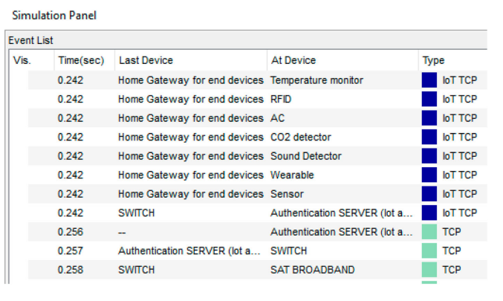

Figure 6: Authentication initiation time

Figure 7: Authentication completion time

The authentication process via a specific satellite broadband channel is the main concern in this simulation of an Internet of Medical Things (IoMT) environment. Here is a concise description of the main conclusions:

**Simulation of the authentication process:**

To simulate the authentication procedure in the IoMT environment, it is necessary to record the "IoT TCP" event.

For 0.5 seconds, this event was watched to gauge the processing time for authentication.

**Starting the authentication process:**

According to Figure 6 in the simulation data, the "IoT TCP" event's authentication procedure starts at 0.236 seconds. The authentication request has officially started at this point.

Authentication for "Temperature Monitor" Device:

The identical "IoT TCP" event in Figure 7 depicts the authorization request for a particular device known as the "temperature monitor."

The gadget known as the "temperature monitor" appears to have successfully finished the authentication procedure because this request was served and fulfilled in the 0.242nd of a second.

Processing Period

It is noteworthy that the authentication event's time stamp, which includes the "temperature monitor," was roughly 0.006 seconds.

All other devices that were taken into consideration within the framework of the e-health infrastructure experienced the same processing time.

In conclusion, the simulation shows that the authentication procedure takes only a little amount of time—roughly 0.006 seconds—in the IoMT environment, including the "temperature monitor" device. The efficient and secure operation of IoMT devices over a private satellite broadband channel is ensured by the rapid authentication processing time. [[6]](https://www.researchgate.net/publication/351812486_Internet_of_Medical_Things_IoMT_Overview_Emerging_Technologies_and_Case_Studies)

1. **Software Defined Networking (SDN) in Healthcare**

**3.1 Concept of SDN in Healthcare:**

Software Defined Networking (SDN) is a network architecture that allows for the centralized control of network resources. In healthcare, SDN has gained prominence due to its ability to provide dynamic and efficient network management. SDN decouples network control and data forwarding, enabling healthcare organizations to adapt their network infrastructure to changing demands. It allows for the creation of virtual networks, optimizing resource allocation. [[6]](https://www.researchgate.net/publication/351812486_Internet_of_Medical_Things_IoMT_Overview_Emerging_Technologies_and_Case_Studies)

**3.2 Relevance of SDN in Healthcare:**

Authentication for "Temperature Monitor" Device:

1. Network resource management optimization

SDN makes it possible to allocate network resources dynamically, which is essential for IoMT systems that use numerous connected medical devices. It makes sure that network resources are utilized effectively and efficiently while taking into account the unique requirements of IoMT devices [7].

1. Enhancing Credibility

In IoMT systems, SDN can increase the reliability of medical items. The centralized control system it offers helps strengthen security and privacy precautions, which are crucial in healthcare applications [7].

1. Keeping an eye on network traffic

The monitoring of network traffic may be done in-depth thanks to the integration of SDN and IoMT. This is necessary for illegal event identification and intrusion detection, both of which are crucial for the security of healthcare data [9].

1. Quality of service (QoS)

In order to guarantee the fast and accurate supply of healthcare data, IoMT devices frequently require specified Quality of Service (QoS) criteria. These QoS requirements can be effectively supported by SDN technologies [8].

1. Programmability and adaptability:

SDN improves the accuracy, adaptability, and programmability of network architectures, which is essential for adjusting to the changing needs of IoMT systems [10].

* 1. **Enhancements in Healthcare Network Management:**

1. Authentication for "Temperature Monitor" Device:

Healthcare network administration is revolutionized by Software-Defined Networking (SDN) in a number of ways.

SDN gives administrators the ability to configure and manage every aspect of the healthcare network from a single controller. The management and control of different network components is made simpler by this centralized method. Research conducted in the real world has demonstrated how this centralized control improves network efficiency and makes network administration jobs simpler [11].

1. Automation:

A major component of SDN, automation lowers the likelihood of human error and speeds up network provisioning. Healthcare organizations can increase network stability and lower the possibility of human mistake influencing crucial healthcare services by automating common network functions. The effects of automation on hospital network management have been thoroughly studied in research publications [12].

1. Authentication for "Temperature Monitor" Device:

Traffic Optimization: A key feature of SDN is dynamic traffic routing, which guarantees that healthcare applications acquire the required network resources instantly. For healthcare systems where delays or network congestion could directly impact patient care, this optimization is essential. The advantages of SDN in streamlining network traffic for healthcare applications have been extensively researched [11].

1. Scalability:

In order to accommodate new services and equipment, healthcare networks constantly change. Healthcare firms may simply extend their network infrastructure thanks to SDN's scalability, which enables them to keep up with rising demand. The scalability advantages of SDN in healthcare environments have been studied in real-world research [13].

* 1. **Security Vulnerabilities in SDN for Healthcare:**

1. Authentication for "Temperature Monitor" Device:

Despite its benefits, SDN may pose security flaws in healthcare environments:

Controller flaws: Attacks may be possible against centralized SDN controllers. The entire healthcare network can be affected if the controller is compromised. In healthcare SDN contexts, mitigation techniques for controller vulnerabilities have been covered in research articles [14].

1. Unauthorized Access:

Bad actors may try to get access to the SDN controller without authorization, which could cause network outages or allow unauthorized parties to access data. The significance of access control systems in healthcare SDN to stop such compromises has been highlighted by real-world studies [14].

1. Data Exfiltration:

In SDN systems, improper network segmentation or misconfigurations can lead to vulnerabilities that could be used for data breaches. Studies have looked into data security techniques and data exfiltration incidents prevention in healthcare SDN networks[15].

* 1. **Real-World Examples:**

1. Authentication for "Temperature Monitor" Device:

The importance of SDN in healthcare and the imperative necessity for strong security measures are highlighted by real-world incidents:

The risks associated with inadequately protected medical devices in SDN systems were made clear by vulnerabilities in St. Jude Medical's pacemakers in 2017. This incident underlined how crucial it is to protect medical IoT devices in SDN networks [16].

1. Targeted Attacks on Healthcare SDNs:

Using SDN vulnerabilities, a number of assaults have particularly targeted healthcare networks. These occurrences serve as sharp reminders of the necessity of putting strong security controls in place in healthcare SDN systems in order to secure patient data and essential healthcare services [16].

1. **Common Cybersecurity Risk , VULNERABILITY ,Threats and Issues Specific to IoMT:**

**4.1. Risk**

The most high risk devices, within the realm of IoMT (Internet of Medical Things) are healthcare workstations. These workstations include DICOM workstations, which we discussed year well as specialized workstations specifically designed for radiology purposes. Other devices that were highlighted in years list are imaging devices, such as imaging machines and patient monitors. These devices are not highly vulnerable but also extensively connected in hospital settings.

A new addition to the list is blood glucose monitors. Blood glucose monitors are frequently used alongside insulin pumps. There have been instances where vulnerabilities have affected these devices and their communication protocols. These vulnerabilities could potentially allow attackers to intercept, replay, inject or manipulate data between these devices. Recent versions of these devices often establish connections, with patients personal devices first before connecting to a supposedly more secure clinical network used by critical medical equipment.

**4.2. Vulnerabilities**

1. Distribution of Device Vulnerabilities:

In our collection, more than 4,000 vulnerabilities have been found.

The majority of vulnerabilities (78% of them) harm IT equipment.

In contrast to OT and IoMT devices, which each contribute 6% and 2% of these vulnerabilities, IoT devices account for 14% of them.

1. Severity Evaluation

According to the CVSS v3 scores, the seriousness of these vulnerabilities is concerning. Amazingly, 96% of cases are rated as being of high or critical severity.

1. Vulnerability Level by Type of Device:

Although many, IT devices are in a little better position because roughly 80% of their vulnerabilities are classified as being of high severity.

IoMT devices, in comparison, are in a hazardous position despite having fewer vulnerabilities, as 80% of them are rated as critical. Typically, attacks of this high degree give the attacker entire control of the targets.

The majority of OT device vulnerabilities are critical.

Implications:

1. A major concern is the severity of vulnerabilities in IoMT and IoT devices. Due to the difficulty in upgrading and patching these specialized equipment, the exposure to these serious vulnerabilities is prolonged.

Essentially, this data highlights the critical need for strong cybersecurity safeguards everywhere, with a focus on IoMT and IoT devices. These results highlight the significance of proactive cybersecurity procedures and ongoing surveillance to safeguard crucial networks and guarantee the security of connected devices in 2023.[[3]](https://www.forescout.com/resources/the-riskiest-connected-devices-in-2023/)

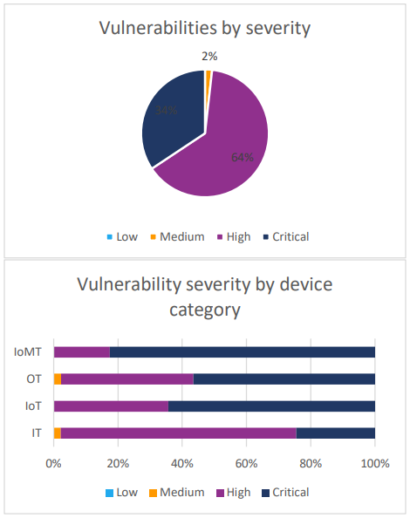

Figer 2 Vulnerability distribution by severity and severity distribution by device category

**4.3.Threat**

What security risks are present in the healthcare sector?

Medical data is more difficult to maintain secure than other forms of data and software, making health systems particularly critical [4]. There are different categories of risks, and each has its own set of root causes and impact on health applications. In this paper, some of these security concerns are discussed. Security issues include eavesdropping, impersonation, communication alterations, and man in the middle. The effects of a cyberattack on an Internet of Things-based health system can be severe, life-threatening, and upsetting: the system may not function, medical equipment may be disconnected, the health information system may become paralyzed, personal information may be disclosed, financial resources may be lost, and patients may pass away.

* Phishing attempts via email:

Imagine receiving an email that appears to be legitimate but is actually from a hacker. Your login information is stolen when you click on a link in that email and enter it. This can result in illegal access to patient data in the healthcare industry.

* RFID Security Flaws:

Imagine someone making a clone of your ID card and using it to impersonate you. RFID flaws in the healthcare industry give attackers the ability to copy RFID tags, tamper with data flow, and potentially undermine the entire RFID healthcare system.

* Eavesdropping Attack:

Consider the possibility of someone listening in on your private discussions. This hack targets healthcare apps by intercepting and eavesdropping on information being transferred, including private health information.

* Message Alteration

Imagine someone editing a letter you wrote before it gets to its intended recipient. Similar to how they can modify data transferred from one party to another, attackers can also intercept data being sent between parties and spread false information.

* Impersonation:

It's similar to someone impersonating you without producing identification. Impersonation in the digital realm refers to the act of sending data while posing as someone else, which poses a security concern.

* Session Med jacking - med jacking during a session

Consider doing this as sneaking into a meeting without permission. Attackers might get unauthorized access to healthcare databases by taking advantage of session security flaws.

* Ransomware

Imagine if you had to pay to open your computer files because they were locked. Data is encrypted by ransomware, which demands payment to decrypt it. This could impede access to patient records in the healthcare industry.

* Denial of service attack:

Consider this to be a backup on the internet. The attacker overwhelms a system during a DoS assault, which makes it lag or crash. This could affect patient care in the healthcare industry by disrupting access to vital medical information.[5]

**4.4. Security issues in IoMT**

#### **Authentication**

Verifying the identification of devices, users, and data inside the healthcare ecosystem is a difficulty for the Internet of Medical Things (IoMT). Due to the variety of IoMT systems, these problems are complicated. They mainly concentrate on the device, network, and user levels.

Authentication at the user-level

Users at the application layer, like patients and healthcare professionals, are affected by this. It's vital to make sure that their identities are confirmed.

The authentication of devices:

This focuses on verifying the legitimacy and security of the devices within the IoMT system through authentication.

Authentication at the network level

For the IoMT to be completely secure, users and devices must be registered and authenticated.

Only authorized users are allowed access to the resources and services provided by IoMT thanks to authentication procedures. It's crucial to assess how well-defended these solutions are against prospective assaults. Forgery, smart card theft, insider attacks, tracking attacks, Denial-of-Service (DoS) attacks, session key breaches, Man-in-the-Middle (MitM) attacks, and desynchronization are all frequent authentication attacks in IoMT.

The ECG-based authentication method is one of note because of its originality, appropriateness, accessibility, and user-friendliness. However, increasing accuracy continues to be difficult, particularly in circumstances with lots of users. To overcome this difficulty, parallel ECG-based authentication (PEA) was developed.

In IoMT, many models and tactics are intended to defend against authentication attacks. These include tactics that combine short-term and long-term parameters, identification methods that protect against guessing and insider attacks, and strategies to ward off MitM and DoS attacks. Furthermore, blockchain-based transaction systems with time and identification stamps improve security by decreasing the likelihood of replay attacks.

**Identifier verification and authorization**

To prevent unwanted access and data manipulation, IoMT relies on strong authentication and permission procedures. Only authorized parties can access particular network resources, such as medical IoT devices and patient data, thanks to proper authentication. Adversaries may take advantage of weak permission, enabling illegal access to IoMT resources. The lack of security awareness among users makes IoMT devices vulnerable to social engineering attacks.

**Effects of Subpar Authorization**

Sensitive medical data misuse, identity theft, and data breaches can all be caused by inadequate IoMT permission. To protect patient data and uphold confidence, it is essential to implement strict authorisation procedures. Compromise in authorisation might even endanger the lives of patients, particularly when it comes to equipment that records vital signs.

**Access Management:**

Permissions for people or groups are defined and enforced using access control techniques like access control lists (ACLs). Scalable and fine-grained access control is provided through decentralized systems like BlendCAC that employ blockchain technology, enhancing performance and reliability.

**Confidentiality of Data:**

It is crucial to safeguard the privacy of medical data. Data transfer is secured using blockchain technology and standards like Transport Layer Security (TLS). By hiding information, steganography gives an added degree of security.

**Availability:**

Making sure data is accessible is essential, particularly in healthcare institutions. IoMT services can be interrupted by assaults like jamming, congestion, and IoT-botnet attacks. To lessen these difficulties and improve availability, a variety of tactics are applied, including decentralized methods.

**Integrity:**

Information accuracy and fidelity are maintained through maintaining data integrity. Data is protected against modification using cryptographic techniques like blockchain and encryption. Integrity must be upheld in order to avoid incorrect diagnosis and protect patient safety.

**Future Perspectives:**

As IoMT continues to grow, it's vital to focus security, privacy, risk assessment, standardization, interoperability, and ethical issues. These components are essential for ethical and secure IoMT deployments that preserve patient privacy and well-being while guaranteeing the confidentiality, integrity, and availability of medical data.

### Potential solutions to the security issues in IoMT

In the IoMT era, protecting healthcare devices from different attacks that could interrupt clinical operations and compromising security is essential. There are several options to deal with these security issues:

**Communication Security:**

Use TLS and other secure communication protocols to protect data being exchanged between IoMT systems and devices. These protocols guarantee the delivery of authenticated and verified data without jeopardizing security.

**Encryption:**

To safeguard data from the point of origin to the point of destination, use robust encryption techniques. This ensures that both the transmission channel and the content are secure by encrypting data at the sender, ensuring secure transmission, and performing decryption at the receiver.

**Access Management:**

To manage data flow within the IoMT ecosystem, use strong access control techniques like Role-Based Access Control (RBAC). Data transmission can be isolated and secured via network segmentation and Virtual Private Networks (VPNs).

**Reciprocal Authentication**

Reduce the risk of attacks from malicious actors by implementing mutual authentication across all devices and gateways to authenticate identities prior to data exchange.

**Detecting and preventing intrusions**

Install intrusion detection and prevention systems to keep an eye on network activity, spot suspicious login attempts and data trends, and take precautionary action.

**Prevention of Data Loss:**

Put safeguards in place to prevent data loss, such as backups, systems for handling packet loss, and protocols for data redundancy or retransmission.

**Managing the Lifecycle of Data:**

In order to protect user privacy and comply with regulations, clearly define the policies for data collection, storage, access, and deletion within the IoMT infrastructure.

**Monitoring and analysis of the traffic**

Utilize network monitoring technologies to track data flows continually and spot any unusual activity.

**Security examinations and audits:**

To find vulnerabilities and implement patches for enhanced data protection, conduct regular security audits and penetration tests.

**Data integrity examinations**

Implement measures such as checksums, digital signatures, and hash functions to assure data accuracy, and carry out regular integrity assessments.

**Security education and awareness**

Inform end users, IT staff, and medical staff about secure handling of sensitive information in transit.

**Updates to Firmware and Software:**

To be protected against new threats and vulnerabilities, IoMT devices, gateways, and network infrastructure should routinely receive firmware and software updates.

Healthcare providers can safeguard patient information, preserve the integrity of the IoMT ecosystem, and lower their risk of data breaches brought on by nefarious activity by implementing these complete security measures. To protect the security and privacy of IoMT systems, cooperation between manufacturers, healthcare organizations, regulatory agencies, and cybersecurity experts is essential.[17]

## **Open issues and challenges in IoMT**

By linking medical equipment, sensors, and healthcare systems, the Internet of Medical Things (IoMT) has the potential to completely change the way that healthcare is provided. However, there are a number of significant obstacles to its general acceptance that must be overcome:

Privacy and Confidentiality: Safeguarding patient data is essential in the healthcare sector due to the growing danger of data breaches and unauthorized access as IoMT devices and data transfer expand.

Dependability and Accessibility: Because system failures or device malfunctions can have disastrous repercussions, it is essential that IoMT tools and infrastructure be dependable and accessible.

Data Integrity is a constant worry due to the importance of accurate and trustworthy data that IoMT devices collect in order to make well-informed medical decisions.

Interoperability: Since IoMT systems and devices sometimes originate from multiple vendors and employ several communication protocols, it can be difficult to guarantee smooth data transfer and communication.

Infrastructure Scalability: Managing and growing the underlying IoMT infrastructure becomes challenging as connected devices and data types proliferate.

Training for Healthcare workers: To use IoMT devices and analyze the data they provide, healthcare workers must have the proper education and training.

Patient Trust: The effectiveness of IoMT technologies and infrastructure depends on patient trust, which must be earned and sustained over time.

Infrastructure and Connectivity: Poor infrastructure and unstable connectivity, especially in rural regions, might cause delays in the implementation of IoMT solutions.

Lack of Universal Standards: Despite efforts to standardize IoMT technology, the integration of various IoMT systems can be hampered by the absence of universal standards.

Security: Hacking and unauthorized access to medical devices can have fatal results, underscoring the importance of taking strong security precautions.

Ethical Concerns: IoMT applications need to address ethical concerns, such as patient consent, data exploitation, and the ethical implications of AI-driven diagnoses.

Ownership of Data: There is continuous discussion about who should be in charge of IoMT device data, including whether it belongs to patients, healthcare professionals, or device makers.[17]

1. **Future Directions**

Future research should focus on a number of key topics due to the Internet of Medical Things' (IoMT) dynamic environment:

Upgrading Legacy Devices: Because IoMT lacks a standardized architecture, some older devices that are unable to receive software upgrades constitute security hazards. Future studies should look into ways to improve these systems and lower the cost of deploying IoMT, particularly for visual surveillance.

IoMT-Specific Policies: Because IoMT deals with sensitive patient data, it is important to create specific policies to protect patients' rights and privacy. Research should concentrate on developing such regulations.

Network-Based Malware identification: Because IoMT is so diverse, malware identification is difficult. It's crucial to look into continuous network-based virus detection techniques, especially in a cross-platform setting.

Handling Heterogeneity: IoMT includes a range of devices, each with a special set of capabilities. The development of specific methods for assault detection within this intricate ecology should be the focus of research.

Increasing Security: Cryptography and blockchain technologies should be investigated as ways to secure IoMT systems. Blockchain can strengthen data integrity and make it easier to spot irregularities in patient data.

Cross-Platform Malware Detection: To maintain patient safety, data privacy, and the general dependability of healthcare services, detecting malware across several IoMT systems is a critical challenge that requires additional investigation.

IoMT's success ultimately hinges on overcoming these obstacles through continual hardware and software research and development, providing a safe and effective healthcare ecosystem.

**8: Conclusion**

In this comprehensive review paper, we have explored the critical landscape of cybersecurity in the healthcare sector, with a particular focus on the Internet of Medical Things (IoMT) and Software Defined Networking (SDN). Here are the key findings and insights:

1. Healthcare Cybersecurity Challenges: We have identified various cybersecurity challenges in healthcare, including data breaches, ransomware attacks, insider threats, and vulnerabilities in legacy systems.
2. Specific Threats from IoMT and SDN: Our analysis revealed specific threats posed by IoMT, such as denial of service (DoS) attacks and malware, and vulnerabilities in SDN controllers and unauthorized access.
3. Mitigation Strategies: We discussed mitigation strategies and best practices to counter these threats, emphasizing the importance of encryption, access control, network segmentation, and compliance with regulatory frameworks.
4. Emerging Technologies: The review highlighted emerging technologies like zero trust security, edge computing, and 5G network security as crucial trends in IoMT and SDN security.
5. Future Research Areas: We suggested promising research areas, including threat intelligence, blockchain in healthcare, AI and ML for anomaly detection, and quantum-safe cryptography.

In conclusion, cybersecurity in healthcare is not just a concern; it is an imperative. Protecting patient data, ensuring the integrity of healthcare systems, and maintaining trust are paramount. The healthcare sector must shift from reactive approaches to proactive measures, investing in advanced technologies, robust security practices, and compliance with regulatory standards.

The importance of healthcare cybersecurity cannot be overstated. It is not only about safeguarding data but also about safeguarding lives. As cyber threats continue to evolve, a proactive stance is essential to protect the healthcare ecosystem and, ultimately, the well-being of patients. It is a shared responsibility among healthcare organizations, policymakers, and technology providers to fortify the defenses and ensure a secure healthcare environment.[17]

**9.** **References:**

[1]. C. Huang, "Internet of medical things: A systematic review," in Proceedings of the IEEE International Conference on Healthcare Informatics (ICHI), 2023, pp. 1-6

[2].D. T. Shah, "Recent Advancements of Internet of Medical Things (IoMT)," in Proceedings of the IEEE International Conference on Healthcare Informatics (ICHI), 2022, pp. 1-6.

[3] Daniel dos Santos, “The Riskiest Connected Devices in 2023”, FORESCOUT RESEARCH

VEDERE LABS, July 13 2023

[4] M. E. J. a. P. H. A. Burns, "A brief chronology of medical device security," Communications of the ACM, vol. 59, pp. 66- 72, 2016.

[5]A. D. a. D. E. Saïdouni, "Cyber Attacks Classification in IoTBased-Healthcare Infrastructure," in 2nd Cyber Security in Networking Conference, 2018.

[6] S. Razdan, "Internet of Medical Things (IoMT): Overview, Emerging Technologies, and Case Studies," in International Journal of Advanced Computer Science and Applications, vol. 12, no. 1, pp. 238-244, 2021, doi: 10.14569/IJACSA.2021.012012.

[7] K. Haseeb, "A Machine Learning SDN-Enabled Big Data Model for IoMT Systems," 2021.

[8] IEEE Reference: P. Radoglou-Grammatikis, "Modeling, Detecting, and Mitigating Threats Against...," 2021.

[9] IEEE Reference: M. Sugadev, "Implementation of Combined Machine Learning with the...," 2022.

[10] IEEE Reference: H. Ahmadvand, "Privacy-Preserving and Security in SDN-Based IoT: A Survey," 2023

[11] K. Wei, "Health Monitoring Based on Internet of Medical Things," 2020

[12] A. Ghourabi, "A Security Model Based on LightGBM and Transformer to Monitor the IoMT," 2022.

[13] K. Haseeb, "A Machine Learning SDN-Enabled Big Data Model for Improving Security Architecture of Internet of Medical Things," 2021.

[14] H. Ahmadvand, "Privacy-Preserving and Security in SDN-Based IoT: A Survey," 2023.

[15] F. Alsubaei, "IoMT-SAF: Internet of Medical Things Security Assessment Framework," 2019

[16] H. Ahmadvand, "Privacy-Preserving and Security in SDN-Based IoT: A Survey," in IEEE Access, 2023.

[17] S. F. Ahmed, "Insights into Internet of Medical Things (IoMT): Data fusion...," IEEE Xplore, 2023